.netCore with Sqlite Entity framework

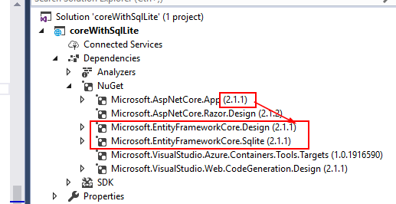

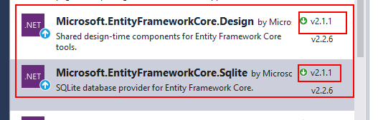

Microsoft.EntityFrameworkCore.Sqlite

Microsoft.EntityFrameworkCore.Design

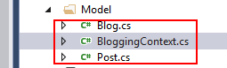

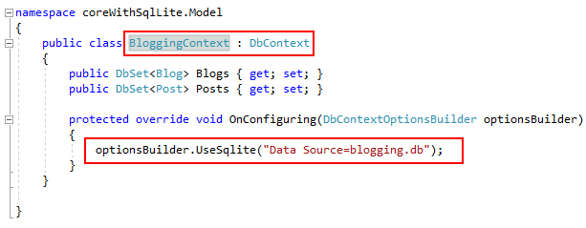

public class BloggingContext : DbContext

{

public DbSet<Blog> Blogs { get; set; }

public DbSet<Post> Posts { get; set; }

protected override void OnConfiguring(DbContextOptionsBuilder optionsBuilder)

{

optionsBuilder.UseSqlite("Data Source=blogging.db");

}

}

public class Post

{

public int PostId { get; set; }

public string Title { get; set; }

public string Content { get; set; }

public int BlogId { get; set; }

public Blog Blog { get; set; }

}

public class Blog

{

public int BlogId { get; set; }

public string Url { get; set; }

public ICollection<Post> Posts { get; set; }

}

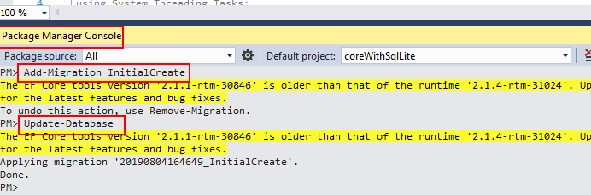

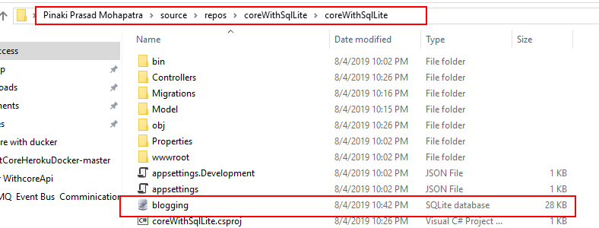

<https://sqlitestudio.pl/index.rvt>

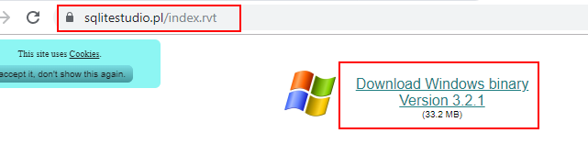



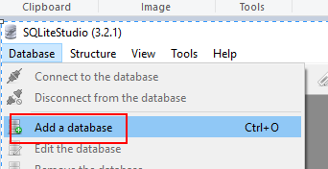

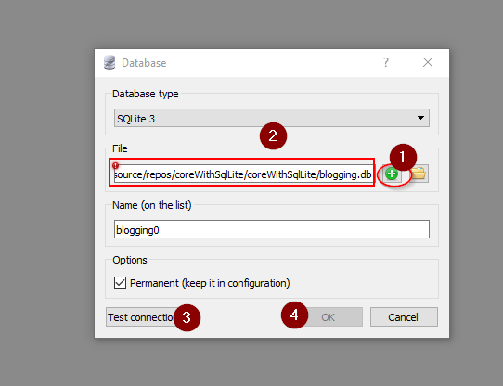

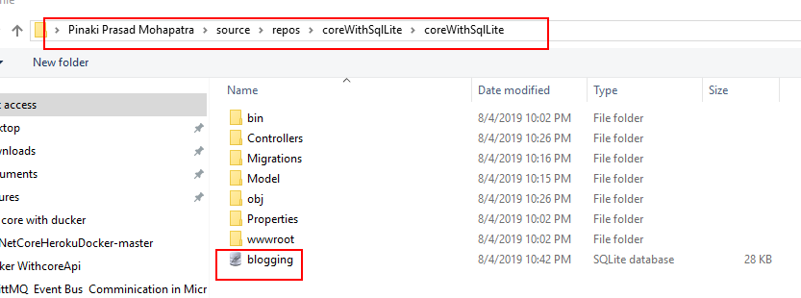

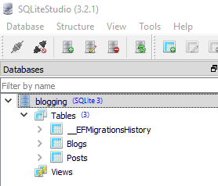

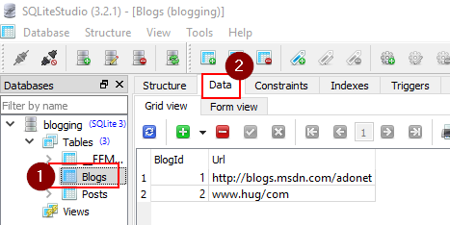

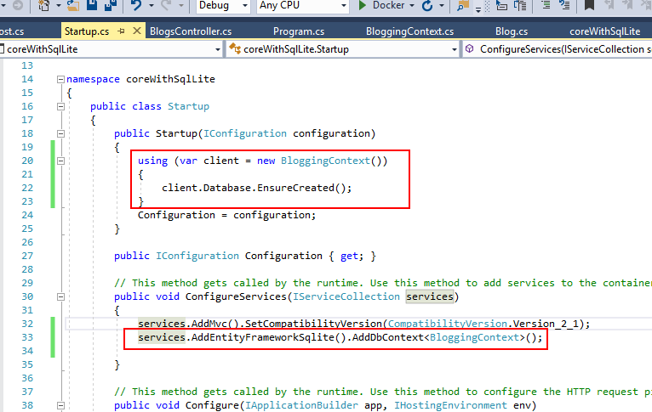

public Startup(IConfiguration configuration)

{

using (var client = new BloggingContext())

{

client.Database.EnsureCreated();

}

Configuration = configuration;

}

services.AddEntityFrameworkSqlite().AddDbContext<BloggingContext>();

